***Assignment –1***

Creating sample tables and inserting values.

Create the following tables with the given structures and insert sample data as specified: -

Besic commands:

1. To create database: ex cdacmumbai

Query: CREATE DATABASE DATABASENAME (EX: cdacmumbai)

To se created database   
Query: show databases;

1. Use database:

Query: use DATABASENAME (EX: cdacmumbai;)

1. *SALESPEOPLE*

Snum int(4)

Sname varchar(10)

City varchar(10)

Comm float(3,2)

Query for creating the table SALESPEOPLE and inserting data int the that table.

Create table:

CREATE TABLE SALESPEOPLE(

Snum INT(4) NOT NULL,

Sname VARCHAR(10),

City varchar(10),

Comm FLOAT(3,2)

);

*SALES PEOPLE*

|  |  |  |  |
| --- | --- | --- | --- |
| SNUM | SNAME | CITY | COMM |
| 1001 | Peel | London | .12 |
| 1002 | Serres | San Jose | .13 |
| 1004 | Motika | London | .11 |
| 1007 | Rifkin | Barcelona | .15 |
| 1003 | Axelrod | New York | .10 |

Insert Query:

INSERT INTO Salespeople (Snum, Sname, City, Comm)

VALUES

(1001, 'Peel', 'London', 0.12),

(1002, 'Serres', 'San Jose', 0.13),

(1004, 'Motika', 'London', 0.11),

(1007, 'Rifkin', 'Barcelona', 0.15),

(1003, 'Axelrod', 'New York', 0.10);

1. *CUSTOMERS*

Cnum int(4)

Cname varchar(10)

City varchar(10)

Rating int(4)

Snum int(4)

Query for creating the table CUSTOMERS and inserting data int the that table.

Create table:

**Query for create Table:**

Create Table CUSTOMERS(

Cnum INT(4),

Cname VARCHAR(10),

City VARCHAR(10),

Rating INT(4),

Snum INT(4)

);

*CUSTOMERS*

|  |  |  |  |  |
| --- | --- | --- | --- | --- |
| CNUM | CNAME | CITY | RATING | SNUM |
| 2001 | Hoffman | London | 100 | 1001 |
| 2002 | Giovanni | Rome | 200 | 1003 |
| 2003 | Liu | San Jose | 200 | 1002 |
| 2004 | Grass | Berlin | 300 | 1002 |
| 2006 | Clemens | London | 100 | 1001 |
| 2008 | Cisneros | San Jose | 300 | 1007 |
| 2007 | Pereira | Rome | 100 | 1004 |

INSERT INTO CUSTOMERS (Cnum, Cname, City, Rating, Snum)

VALUES

(2001, 'Hoffman', 'London', 100, 1001),

(2002, 'Giovanni', 'Rome', 200, 1003),

(2003, 'Liu', 'San Jose', 200, 1002),

(2004, 'Grass', 'Berlin', 300, 1001),

(2006, 'Class', 'Landon', 100, 1007),

(2008, 'Cisneros', 'San Jose', 300, 1007),

(2007, 'Pereira', 'Rome', 100, 1004);

1. *ORDERS*

Onum int(4)

Amt float(7,2)

Odate date

Cnum int(4)

Snum int(4)

Query for creating the table Orders and inserting data int the that table.

Create table:

**Query for create Table:**

Create Table ORDERS(

Onum int(4),

Amt float(7,2),

Odate date,

Cnum int(4),

Snum int(4)

);

*ORDERS*

|  |  |  |  |  |
| --- | --- | --- | --- | --- |
| ONUM | AMT | ODATE | CNUM | SNUM |
| 3001 | 18.69 | 03-OCT-1990 | 2008 | 1007 |
| 3003 | 767.19 | 03- OCT -1990 | 2001 | 1001 |
| 3002 | 1900.10 | 03- OCT -1990 | 2007 | 1004 |
| 3005 | 5160.45 | 03- OCT -1990 | 2003 | 1002 |
| 3006 | 1098.16 | 03- OCT -1990 | 2008 | 1007 |
| 3009 | 1713.23 | 04- OCT -1990 | 2002 | 1003 |
| 3007 | 75.75 | 04- OCT -1990 | 2004 | 1002 |
| 3008 | 4723.00 | 05- OCT -1990 | 2006 | 1001 |
| 3010 | 1309.95 | 06- OCT -1990 | 2004 | 1002 |
| 3011 | 9891.88 | 06- OCT -1990 | 2006 | 1001 |

INSERT QUERY FOR ORDERS:

INSERT INTO ORDERS(Onum, Amt, Odate, Cnum, Snum)

VALUES

(3001, 18.69, '1990-10-03', 2008, 1007),

(3003, 767.19, '1990-10-03', 2001, 1001),

(3002, 1900.10, '1990-10-03', 2007, 1004),

(3005, 5160.45, '1990-10-03', 2003, 1002),

(3006, 1098.16, '1990-10-03', 2008, 1007),

(3009, 1713.23, '1990-10-04', 2002, 1003),

(3007, 75.75, '1990-10-04', 2004, 1002),

(3008, 4723.00, '1990-10-05', 2006, 1001),

(3010, 1309.95, '1990-10-06', 2004, 1002),

(3011, 9891.88, '1990-10-06', 2006, 1001);

Query OK, 10 rows affected (0.01 sec)

Records: 10 Duplicates: 0 Warnings: 0.

Show tables;

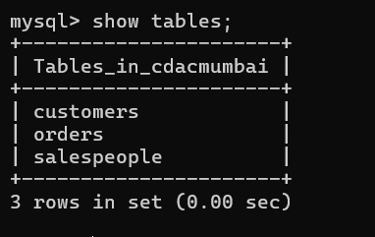

1. *SALESPEOPLE*

Query

Select * from salespeople;

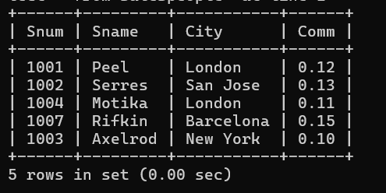

1. CUSTOMERS

Query :

select * from CUSTOMERS;

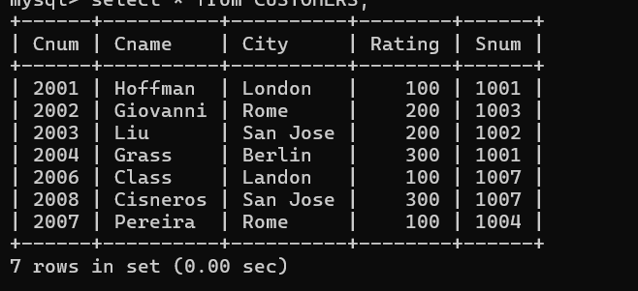

1. Orders:

Query:

select * from ORDERS;

